Following reports are for 32-bit configuration

Design gives priority for performance

Used tool: Quartus Prime

Resource usage:

Board: DE10 Lite Terasic

Family: MAX 10

Device: 10M50DAF484C7G

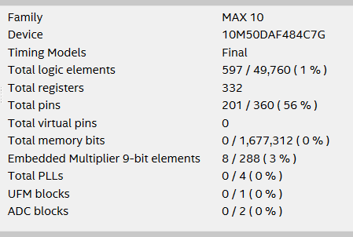

Max frequency

Fmax for design.v by operational conditions:

Fast 1200mV 0C Model: 238.66 MHz

Slow 1200mV 0C Model: 110.63 MHz

Slow 1200mV 85C Model: 100.14 MHz